Contoh Soal UKK Bahasa Inggris Kelas 2 SD Terbaru beserta Kunci Jawaban

Bahasa Inggris merupakan bahasa asing yang wajib dipelajari bagi setiap siswa di Indonesia. Pembelajaran bahasa Inggris sudah mulai dipelajari siswa di jenjang tk dan sekolah dasar. Berikut adalah contoh soal ujian kenaikan kelas bahasa Inggris untuk kelas 2 SD terbaru beserta kunci jawaban.

I. Choose the correct answer of the option A, B, or C!

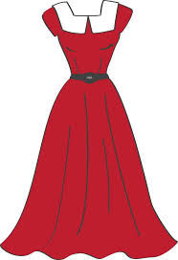
1. My sister is wearing a ...
- Shirt
- Long dress
- Vest

2. Mr. Irfan wears a ...
- Hat
- Socks
- Tie

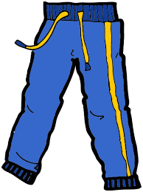
3. Look at the picture beside!
It is a ...
- Coat
- Shirt
- Trousers

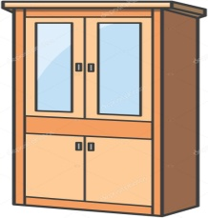
4. It is a ...
- Door
- Cupboard
- Window

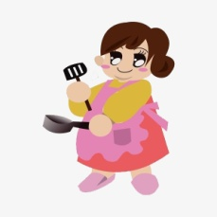
5. My ... is cooking in the kitchen.
- Mother
- Father
- Brother

6. Mr. Rizal is my ...
- Grandfather
- Mother
- Grandmother

7. I have 3 ... in our family.
- Brothers
- Sisters
- Fathers

8. My family watches TV in the ...
- Bathroom
- Kitchen
- Living room

9. Yana wants to sleep, so she goes to ...
- Dining room
- Kitchen
- Bedroom
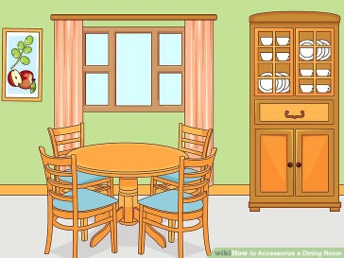
10. Doni : Where are you?
Mirna : I am in the ...
- Kitchen
- Dining room
- Bathroom

11. Ms. Hanna likes to cook some food in the ...
- Bathroom
- Kitchen
- Living room

12. I take a bath in the ...
- Bathroom
- Dining room
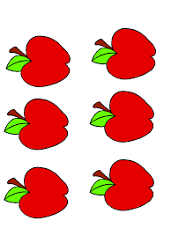
- Living room

13. There are ... apples.
- Five
- Six
- Seven

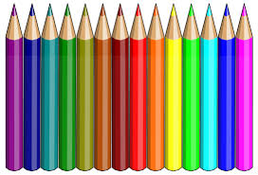
14. Metta : How many pencils do you have?
Rachel : I have ... pencils.
- Ten
- Eleven
- Twelve

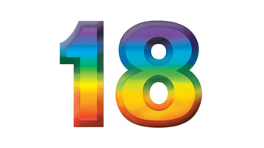
15. What number is it? It is ...
- Eighteen
- Nineteen
- Sixteen
16. The number after twenty is ...
- Twenty one
- Twenty two
- Twenty six
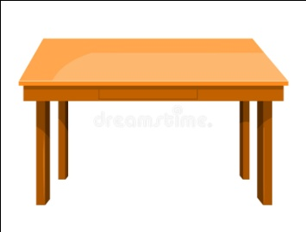
17. This is a ... to put something.
- Table
- Chair
- Box
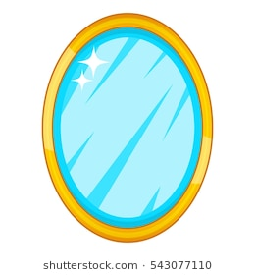
18. What is this? This is a ...
- Table
- Mirror
- Pencil

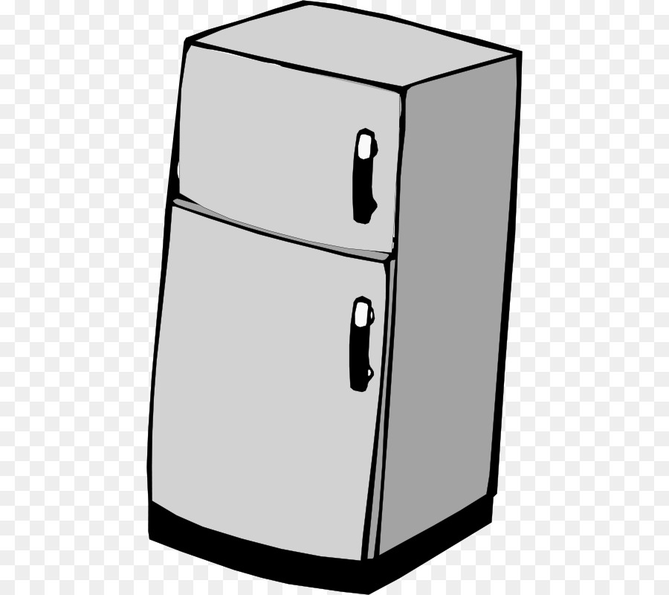
19. ... is used to keep vegetables and fruits.
- Basket
- Table
- Refrigerator

20. Kiki drinks a ... of tea.
- Bottle
- Cup
- Bowl

II. Fill in the blanks with the correct answer.

1. What are you doing?
I am wearing .............................

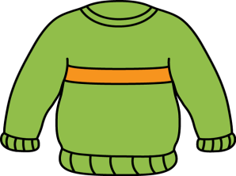
2. We wear ........................... when it is cold.

3. It is “ h – s – i – r – t “
Arrange the jumbled letters into ...............................

4. Mr. Dino is reading a newspaper.
He is my .................................

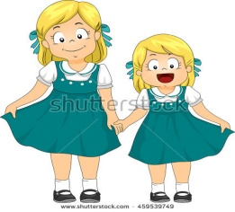

5. My ............................ are playing in the garden.

6. Can you give me the .................................... please?
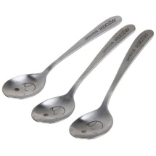

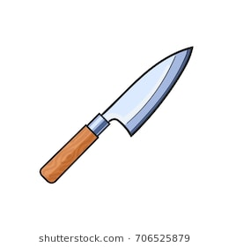

7. We use a .................................. to cut an apple.

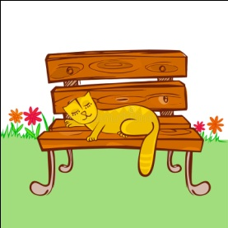

8. Dina : Where is the cat?
Fito : It is on the ........................................
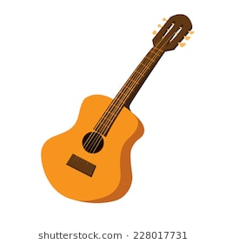

9. Jhon is playing a .......................................

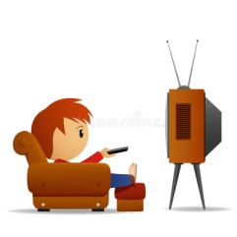
10. I watch .................................... at 5 o’clock.

III. Fill in the blanks with the correct answer from the box.

chair banana flower book door
plane watermelon pencil jacket car

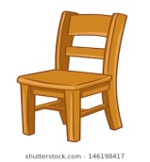
1. What is it?
It is a ...........................
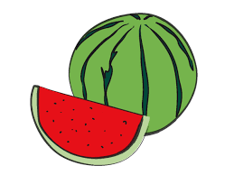
2. What is it?
It is a ...........................
3. What is it?
It is a ...........................

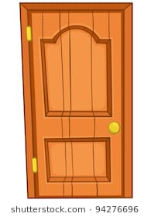
4. What is it?
It is a ...........................

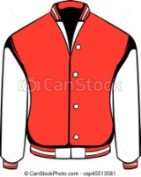
5. What is it?
It is a ...........................

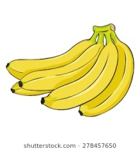
6. What is it?
It is a ...........................

7. What is it?
It is a ...........................

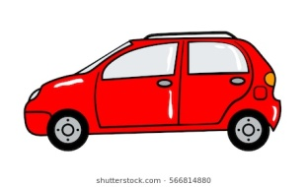
8. What is it?
It is a ...........................
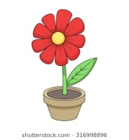

9. What is it?
It is a ...........................

10. What is it?
It is a ...........................

IV. Arrange these words into good sentences.

1. likes – Sari – butterfly
....................................................................
2. are – tigers – They
....................................................................
3. Hana – a fish – has
....................................................................
4. The birds – fly – can
....................................................................
5. eats – carrot – A rabbit
....................................................................

Kunci Jawaban:

I.
- B. Long dress
- C. Tie
- C. Trousers
- B. Cupboard
- A. Mother
- A. Grandfather
- A. Brothers
- C. Living room
- C. Bedroom
- B. Dining room
- B. Kitchen
- A. Bathroom
- B. Six
- C. Twelve
- A. Eighteen
- A. Twenty one
- A. Table
- B. Mirror
- C. Refrigerator
- B. Cup

II.
- Socks
- Sweater/ jacket
- Shirt
- Father/ uncle/ brother
- Friends/ sisters/ cousins
- Spoon
- Knife
- Bench/ chair
- Guitar
- TV/ television

III.
- It is a chair
- It is a watermelon
- It is a book
- It is a door
- It is a jacket
- It is a banana
- It is a pencil
- It is a car
- It is a flower
- It is a plane

IV.
- Sari likes butterfly
- They are tigers
- Hana has a fish
- The birds can fly
- A rabbit eats carrot

Demikianlah contoh soal ujian kenaikan kelas (UKK) bahasa Inggris untuk kelas 2 SD terbaru beserta kunci jawabannya. Semoga contoh soal tersebut dapat berguna sebagai bahan belajar. Terima kasih.

